|  |  | GRAMMAR ACTIVITIES  UNIT 1 |  |
| --- | --- | --- | --- |

# **REPORTED SPEECH**

*Reported speech, or indirect speech, is used to tell what someone has said without using the exact words that person said.*

*EXEMPLES*

*She said she was coming to class* (Ella dijo que iba a venir a clase).  
*I told you I wouldn’t be able to come* (Te dije que no podría venir).  
*You said you would help me!* (¡Dijiste que me ayudarías!).

## REPORTED SPEECH CHANGES

* **PRONOUMS:** It’s necessary to adapt personal pronouns, according to the person to whom they refer and to whom you are speaking:   
  Estilo directo:  
  ***I am****happy to drive****you****to the airport.  
  Me alegra llevarte en coche al aeropuerto.*

Reported speech o estilo indirecto:  
***She said she was****happy to drive****me****to the airport.***Dijo que se alegraba** de llevar**me** al aeropuerto.

* **VERB TENSE:** The verb tense is **modified** depending on how it relates to the present moment, which generally involves moving it to the past (for example, from the simple present to the simple past)  
  Estilo directo:  
  *I* ***am****happy to drive you to the airport.*Me alegra llevarte en coche al aeropuerto.

Reported speech o estilo indirecto:  
*She said she* ***was****happy to drive**me to the airport.***Dijo que se alegraba** de llevarme al aeropuerto.

* **INTRO**: In Reported speech, an introduction is added (“He said that…”, “He asked if…”) to present what that person commented.
  + **SAY OR TELL?** Utilizaremos el TELL/TOLD cuando la persona está contando algo otra.

## VERB TENSE RULES

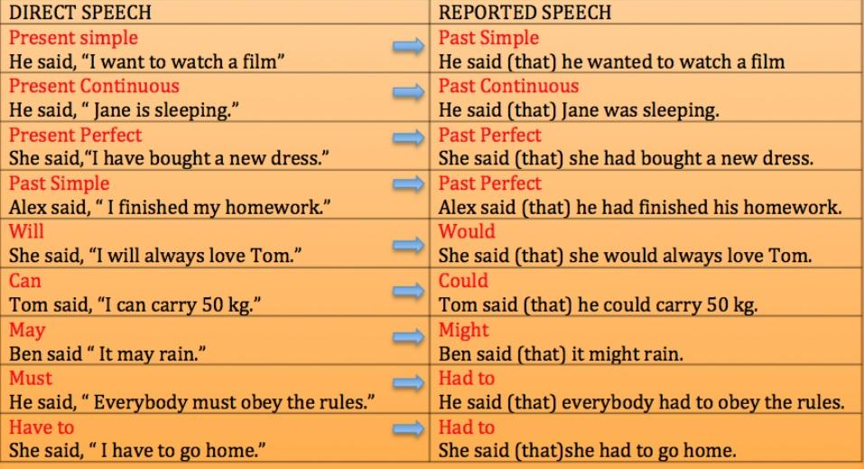

## ADVERBS CHANGES

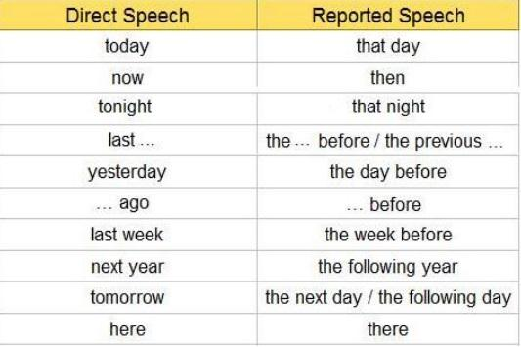

**QUESTIONS**

**We will use the verb “ask” to introduce Reported Speech.**

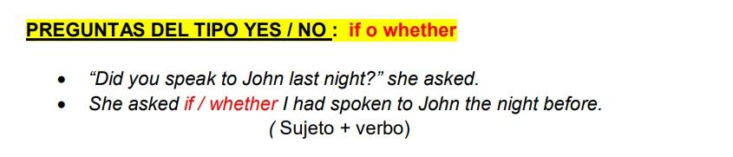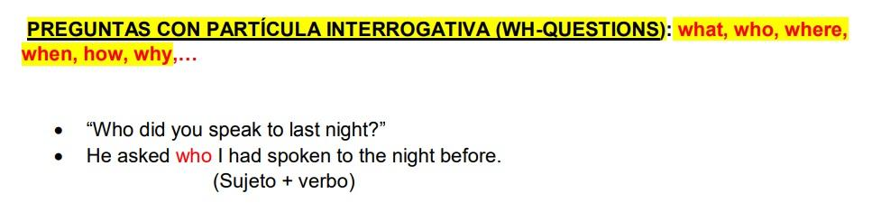

**IMPERATIVE: ORDERS**

**En el imperative, al pasarlo a Reported Speech usaremos ORDER/TELL. Si la oración es afirmativa la estructura será TO+ VERB, Si por el contrario, es negativa, la estructura será NOT TO + VERB**

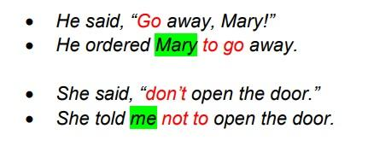

**SUGGESTIONS**

**To convert a suggestion into Reported Speech, we will use SUGGEST and it can be followed by:**

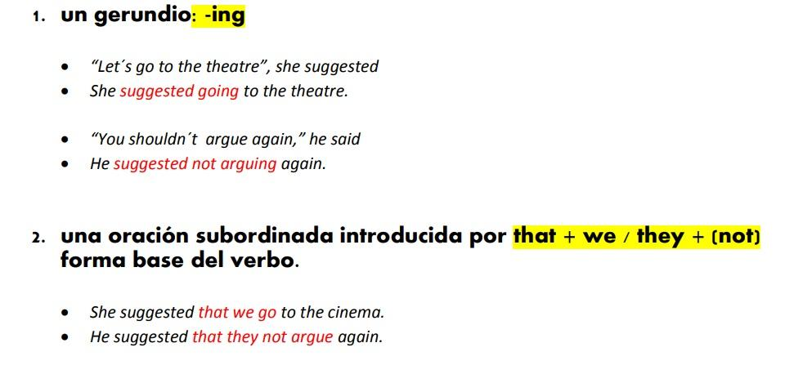

**Change the following sentences to reported speech:**

1. "I am preparing the presentation for the client tomorrow," said the manager.
2. "We have finished the project on time," said the team leader.
3. "I will send you the contract by the end of the day," said the HR manager.
4. "I need to review the budget before the meeting," said the accountant.
5. "They are hiring more developers for the project," said the supervisor.

**Transform the following sentences into negative reported speech:**

1. "I am not attending the job fair next week," said the marketing assistant.
2. "We haven't received the feedback from the client yet," said the project manager.
3. "I won't accept the job offer," said the candidate.
4. "The company is not planning to expand internationally this year," said the CEO.
5. "I didn't complete the training course," said the new employee.

**Change the following questions to reported speech:**

1. "Are you working on the presentation?" asked the manager.
2. "When will you finish the report?" asked the director.
3. "Have you applied for the promotion?" asked the team leader.
4. "Why didn’t you attend the meeting?" asked the HR manager.
5. "Will you be able to join the team next month?" asked the recruiter.